WE NEED YOUR SUPPORT….
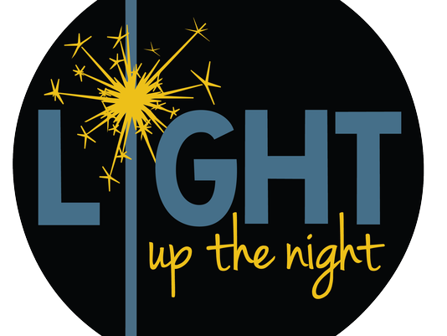
Ponsonby Recreation Park
5997 2nd Line E., RR#2
Ariss, Ontario
N0B 1B0

May 25, 26,
3-Pitch Tournament

27, 28 2017

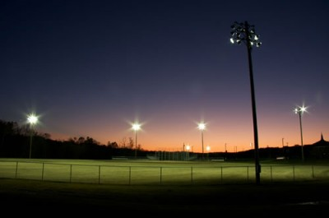
Register Early!

Tournament:
3 Divisions: Competitive $350/team
• Recreational $300/team
• Family/Fun $20/Player
- Guaranteed 3 games (7 innings or 50 mins)
  - Complete list of rules to follow

Silent Auction • BBQ • Beer Gardens • Bake Sale
All Proceeds Going To NEW
Diamond Lights at Ponsonby Recreation Park

For more information or to enter a team contact:
John Cunningham 519-831-0601 jjcunningham_13@hotmail.com
Shirley Obergan 519-846-8113
Or check out our Facebook Page: Light up the Night! 3 Pitch Tourney

