Toronto Blue Jays Tickets Raffle

Ponsonby Recreation Club is holding a raffle to raise funds for minor ball.
The winning ticket to be drawn on Sunday June 9th 5pm at the park.

Tickets available at the booth or by email to ponsonbyrecclub@gmail.com
Tickets $5. each or 3 for $10.

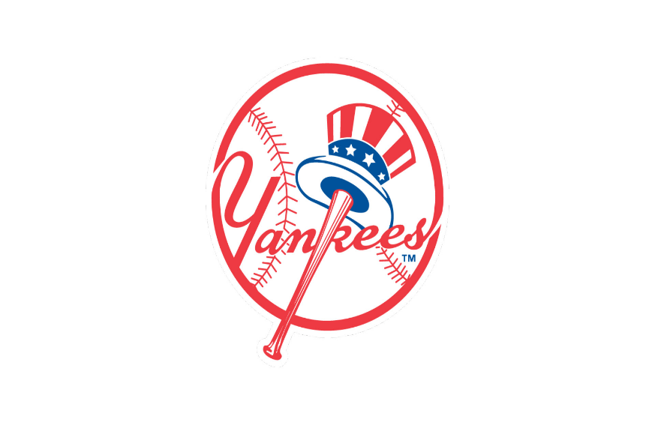
Toronto Blue Jays vs New York Yankees
Sun • June 30, 2024, • 01.37 PM
Toronto, ON — Rogers Centre
4 Seats
Section 128 Row 13 Seats 1 thru 4

